3.8 Maxima and Minima of Functions of Two Variables Worksheet

- True or False: Every function has at least one local maximum.

- Suppose that is a differentiable function and . Determine if each of the following are True or False.
- If f has a local maximum or minimum at , then it always satisfies .
- If , then f has a local maximum or minimum at .
- If f has a local minimum at , then and .

- Find all critical points of the function .

- Find the critical points of and classify them as local maxima, local minima, or saddles points.

- Let be a function of two variables and suppose is a critical point of f. Furthermore, suppose:
Is a local minimum, local maximum, or neither?

- Find the local maximum and minimum values and saddle points of the function .

- Find the critical points of and classify them as local maxima, local minima, or saddles points.

- Consider the following four regions in the plane.
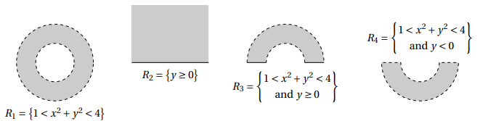

- Classify each region as either open, closed, or neither.

- Classify each region as either bounded or unbounded.

- Let be a differentiable function on the disk in , where
- for every point on the circle .
- f has only one critical point, which is at .
Decide which of the four statements below is true.

- The relationship between cannot be determined from the given information.

- Find the absolute maximum and minimum values of on the rectangle given by .

- Find the absolute maximum and minimum values of on region .

- Consider again the function on region as in #11.
- Why would it be inconvenient to divide the boundary of D into two curves with formulas ?

- What would the function need to look like so that dividing the boundary of D into two curves with formulas would be convenient to use?

- Find the absolute maximum and minimum values of on the triangle with vertices .

